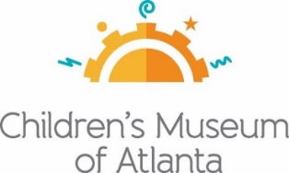
For More Information:
Sarah Wynn Benton
BRAVE Public Relations
404.233.3993
sbenton@emailbrave.com

*MEDIA ADVISORY*

Children’s Museum of Atlanta Enters Final Weeks of
Storyland: A Trip Through Childhood Favorites Featured Exhibit™
Last chance for families to experience book-based exhibit May 30

ATLANTA – (May 12, 2022) – Families have just a few weeks left to experience seven beloved and award-winning picture books come to life at Children’s Museum of Atlanta as the featured exhibit, Storyland: A Trip Through Childhood Favorites™, is set to close on May 30. The imaginative, book-based experience transforms these family-favorite stories into three-dimensional play and bi-lingual learning environments. Families can be immersed in the wonderful world of books as children explore literacy skills and concepts through imaginative, interactive journeys and dramatic play.

WHAT: Final weeks to visit Storyland: A Trip Through Childhood Favorites Exhibit™

WHEN: Available through Monday, May 30
2 three-hour sessions Sunday-Tuesday and Thursday-Saturday
Session A: 9:30 a.m. – 12:30 p.m. / Session B: 1:30 – 4:30 p.m.

WHERE: Children’s Museum of Atlanta
275 Centennial Olympic Park Drive NW
Atlanta, GA 30313

HOW: Tickets must be purchased or reserved in advance at childrensmuseumatlanta.org.

Storyland: A Trip Through Childhood Favorites™ is presented by Target and Institute of Museums and Library Services, with support from Children’s Museum of Atlanta’s generous sponsors, including Children’s Healthcare of Atlanta and Fulton County Arts & Culture through the Fulton County Board of Commissioners and the Mayor’s Office of Cultural Affairs.

For more information or to support the Museum, visit childrensmuseumatlanta.org or call 404.659.KIDS [5437].

###

